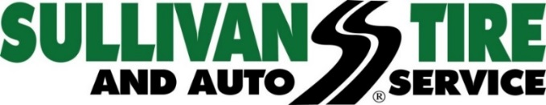

Media Contact: Madison Sheffer
msheffer@regancomm.com 617.488.2836

FOR IMMEDIATE RELEASE

SULLIVAN TIRE ACQUIRES TOM LYONS TIRE IN WALTHAM, MA.
Sullivan Tire now has 69 retail locations across New England

NORWELL, MA (September 11, 2017) – Sullivan Tire and Auto Service has acquired Tom Lyons Tire & Auto Service located at 210 Lexington Street in Waltham, MA, which will officially become Sullivan Tire’s 69th full-service tire and automotive facility on Monday, September 11, 2017. The location, which opened for business in 1953, consists of a full-service tire and automotive center that is 7,600 square feet with ten service stalls, as well as a 15,000 square-foot wholesale warehouse and distribution facility. The location will undergo extensive renovations in the upcoming months but will remain open for business during that time.

"Tom Lyons Tire, and the Garzone family, have done a wonderful job serving Waltham and the surrounding communities for many, many years and we are thrilled to have this opportunity to continue that great tradition in the Sullivan Tire way,” said Paul Sullivan, Vice President of Marketing at Sullivan Tire.

Many of the existing Tom Lyons Tire staff will be staying on as Sullivan Tire employees and Sullivan Tire will honor all Tom Lyons warranty work.

“We’ve known the Sullivan Tire family for a long time and respect the way they do business so this was the perfect fit for us,” said former location owner Mike Garzone. I’m thankful for the many loyal customers over the years and hardworking employees. “We know our customers and staff will be in good hands with the Sullivan Tire team, and I look forward to remaining active in the business.”

For more information or for a complete list of Sullivan Tire locations, visit www.sullivantire.com.

About Sullivan Tire
Sullivan Tire is a locally owned, family business started by Robert J. Sullivan in 1955. The foundation on which Robert J. Sullivan started Sullivan Tire was “treat everyone, customers and fellow employees, as you would a member of your family.” More than sixty years later, the tradition continues. Today, Sullivan Tire is New England’s home for automotive care and commercial truck service with over 100 locations throughout Massachusetts, New Hampshire, Connecticut, Rhode Island and Maine. For more information about Sullivan Tire or to find a location, visit www.sullivantire.com.

###

