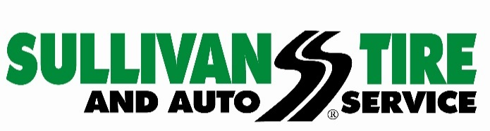
Media Contact: Madison Sheffer
msheffer@regancomm.com
617.488.2836

FOR IMMEDIATE RELEASE

Sullivan Tire and Auto Service Launches Redesigned Website
Norwell, MA (July 27, 2017) – Sullivan Tire and Auto Service has launched a newly redesigned website, www.sullivantire.com, to enhance the user experience for visitors seeking both automotive and commercial truck services.

The upgraded website, which took over a year to complete, was built using responsive web design technology, making it compatible with all devices including mobile. The new site is user-friendly and easy to navigate, allowing customers to search for the right tires, make a tire and auto service appointment, or find the closest Sullivan Tire location along with information on the manager and recent customer reviews.

“We redesigned our website with our customers in mind,” said Mark Gillard of Sullivan Tire’s Marketing Department. “It is easy to navigate with the kind of highly visual content that customers want at their fingertips in order to make their experience more personal. New features include an enhanced 3-step process enabling users to easily schedule appointments for both tire and auto service at any of our 67 locations, or chat with an expert through a toll-free number or live chat.”
Visitors can easily access information on Sullivan Tire products, services, deals, and corporate background and with the newly launched website, Sullivan Tire is able to showcase engaging and educational multimedia content on a variety of relevant topics and better serve as a resource for consumers and industry professionals alike.

About Sullivan Tire and Auto Service:
Sullivan Tire is a locally owned, family business started by Robert J. Sullivan in 1955. The foundation on which Robert J. Sullivan started Sullivan Tire was “treat everyone, customers and fellow employees, as you would a member of your family.” More than sixty years later, the tradition continues. Today, Sullivan Tire is New England’s home for automotive care and commercial truck service with over 100 locations throughout Massachusetts, New Hampshire, Connecticut, Rhode Island and Maine. For more information about Sullivan Tire or to find a location, visit www.sullivantire.com.

###

