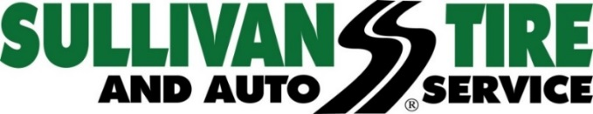

Media Contact: Madison Sheffer
msheffer@regancomm.com 617.488.2836

FOR IMMEDIATE RELEASE

SULLIVAN TIRE OFFERS A CHANCE TO SCORE A MEET AND GREET WITH THE NEW ENGLAND REVOLUTION
Revs fans can enter for a chance to win tickets, gear and a special meet and greet

NORWELL, MA (September 11, 2017) – Sullivan Tire and Auto Service has teamed up with Continental Tire to offer four lucky winners a New England Revolution Meet and Greet Prize Package, including four New England Revolution scarves, four tickets to the home game on September 30th and a meet and greet opportunity with two players on the field after the game.

“As part of a partnership with Continental Tire, we are thrilled to create this contest and give 16 lucky New England Revolution fans the opportunity to attend a game and meet some of the players,” said Mark Gillard, Marketing Director for Sullivan Tire. “The Revs have done a great job providing a family-friendly atmosphere and the New England soccer fan base is terrific. We look forward to hosting the winners on September 30th.”

The contest ends on September 24, 2017 at 11:59pm and winners will be drawn the next morning. No purchase necessary.

For more information and to enter to win, visit https://www.sullivantire.com/new-england-revolution-meet-and-greet-giveaway.

About Sullivan Tire
Sullivan Tire is a locally owned, family business started by Robert J. Sullivan in 1955. The foundation on which Robert J. Sullivan started Sullivan Tire was “treat everyone, customers and fellow employees, as you would a member of your family.” More than sixty years later, the tradition continues. Today, Sullivan Tire is New England’s home for automotive care and commercial truck service with over 100 locations throughout Massachusetts, New Hampshire, Connecticut, Rhode Island and Maine. For more information about Sullivan Tire or to find a location, visit www.sullivantire.com.

###

