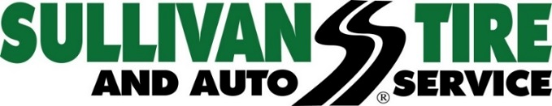

FOR IMMEDIATE RELEASE

SULLIVAN TIRE ACQUIRES MONTVALE TIRE CAR CARE CENTERS

NORWELL, MA (September 11, 2018) – Sullivan Tire and Auto Service has acquired Montvale Tire Car Care Centers. The acquisition includes two locations - 365 Main Street, Melrose MA, and 221 Montvale Avenue, Woburn MA. They are officially Sullivan Tire and Auto Service locations effective Tuesday, September 11, 2018, bringing the total Sullivan Tire Auto Service Centers to 71. Both locations will undergo renovations in the upcoming months but will remain open for business during that time.

"We are thrilled to once again have this opportunity to grow our footprint in New England. These locations are a perfect fit for our growth strategy. Former owner Tony Koles has been a fixture in these communities for nearly 50 years and has a very loyal customer base. We will certainly continue his legacy by treating each customer as a member of our family,” said Paul Sullivan, Vice President of Marketing at Sullivan Tire.

Many of the existing Montvale Tire staff will be staying on as Sullivan Tire employees and Sullivan Tire will honor all of Montvale Tire’s warranty work.

For more information or for a complete list of Sullivan Tire locations, visit www.sullivantire.com.

About Sullivan Tire
Sullivan Tire is a locally owned, family business started by Robert J. Sullivan in 1955. The foundation on which Robert J. Sullivan started Sullivan Tire was “treat everyone, customers and fellow employees, as you would a member of your family.” More than sixty years later, the tradition continues. Today, Sullivan Tire is New England’s home for complete automotive care, commercial truck service repair and wholesale distribution with over 100 locations throughout Massachusetts, New Hampshire, Connecticut, Rhode Island and Maine.
###

